Complete the following tasks that pertain to Chapter 5 & Chapter 6 of the textbook.

1. Create two sequences for populating the INO column of the RATING & BID table. Each sequence generates integer’s minimum value 999 and maximum value 1229. The options should be set to not cycle the values and not cache any values. The names should be BID_INO_SEQ & RATING_INO_SEQ.

*SQL statement goes here*

*create sequence BID_INO_SEQ increment by 1 minvalue 999 maxvalue 1229 nocycle nocache;*

*SQL statement goes here*

*create sequence RATING_INO_SEQ increment by 1 minvalue 999 maxvalue 1229 nocycle nocache;*

1. Create a sequence for populating the BUYERID column of the BID table. The sequence generates an integer minimum value 1 and maximum value 998. The options should be set to not cycle the values and not cache any values. The name should be BID_BUYERID_SEQ.

*SQL statement goes here*

*create sequence BID_BUYERID_SEQ minvalue 1 maxvalue 998 nocycle nocache;*

1. Change the data type for the column BUYERID for the table bid to number(3);

*SQL statement goes here*

*alter table bid modify(BUYERID number(3));*

1. Create and run INSERT statements, to insert the data below into the BID table. Use the BID_INO_SEQ and the BID_BUYERID_SEQ you created in #1 & #2 above for the INO and BUYERID respectively.

|  |  |
| --- | --- |
| BIDPRICE | TIMEOFBID |
| 15 | 26-Jan-08 |
| 6 | 26-Mar-08 |
| 10 | 6-Mar-08 |
| 10 | 20-Nov-07 |
| 7 | 5-Mar-08 |
| 12.5 | 10-Mar-08 |
| 8 | 26-Jan-08 |
| 10 | 4-Apr-08 |
| 40 | 8-Apr-08 |
| 50 | 10-Apr-08 |
| 80 | 10-Apr-08 |
| 25 | 20-Apr-08 |
| 28 | 19-Apr-08 |
| 20 | 18-Apr-08 |
| 30 | 15-Apr-08 |
| 32 | 14-Apr-08 |
| 31 | 8-Apr-08 |
| 15 | 10-Apr-08 |
| 44 | 28-Mar-08 |
| 85 | 3-Apr-08 |
| 23 | 29-Mar-08 |
| 60 | 1-Apr-08 |
| 50 | 6-Apr-08 |
| 27 | 28-Mar-08 |
| 110 | 31-Mar-08 |
| 605 | 2-Apr-08 |
| 30 | 1-Apr-08 |
| 75 | 2-Apr-08 |
| 8 | 6-Apr-08 |
| 10 | 9-Apr-08 |
| 8 | 8-May-08 |

*SQL statements goes here*

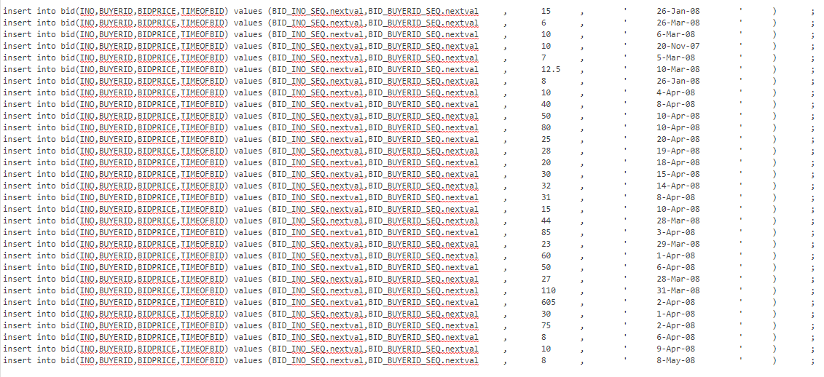*.*

1. Create a sequence for populating the AGENT_CODE column of the AGENT table, named AGENT_AGENT_CODE_SEQ.

*SQL statement goes here*

*create sequence AGENT_AGENT_CODE_SEQ increment by 1 minvalue 504 maxvalue 505 nocycle nocache;*

* 1. What should the minimum value be based on the existing data in the table?

504 that is because the existing data in the table is until 503 so the minimum value should be 504

* 1. Make the maximum value 505.

1. Insert the following data,

*INSERT INTO AGENT(AGENT_CODE, AGENT_LNAME) VALUES (AGENT_AGENT_CODE_SEQ.NEXTVAL, ‘VADAR’);*

*INSERT INTO AGENT(AGENT_CODE, AGENT_LNAME) VALUES (AGENT_AGENT_CODE_SEQ.NEXTVAL, ‘SOLO’);*

*INSERT INTO AGENT(AGENT_CODE, AGENT_LNAME) VALUES (AGENT_AGENT_CODE_SEQ.NEXTVAL, ‘C3PO’);*

What happens, in your own words?

*Answer goes here*

*Its going to be invalid because it exceed the max value*

1. Delete the two records, 504 and 505 from the AGENT table, what is the command?

*SQL statement goes here*

*delete from agent where AGENT_CODE= 504 or AGENT_CODE=505 ;*

1. Create an index of the first and last name in the CUSTOMER_X table, use the name: CUSTOMER_x_NAME_IDX.

*SQL statement goes here*

*create index CUSTOMER_x_NAME_IDX on CUSTOMER_X (CUS_FNAME,CUS_LNAME);*

1. Lock table CUSTOMER_X in the exclusive mode, and table ITEM in the share mode:

*SQL statement goes here*

*lock table CUSTOMER_X in exclusive mode;*

*SQL statement goes here*

*lock table ITEM in share mode;*

1. What is the difference?

*Answer goes here*

Exclusive lock no one can read it because its still being written

Share lock they all can read what is on it.